EXPLORE THE WORLD WITH SHEAFE’S FLAT BLUEBIRD
Due: Friday, February 24, 2012

STUDENT NAME: ___________________________________________________ ROOM _____________

Hi there again from Asia. I’m leaving China and flying southwest to the large country of India. It stretches 2,050 miles from the Himalaya Mountains to Cape Comorin.
On a map of a country, a capital city is marked with a star. On the map below, India’s capital city is marked with a star. Circle the name of the city and write it below.
_________________________________________________________________________
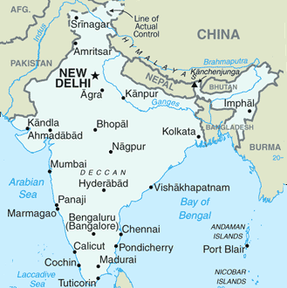

Looking for more of a challenge… turn the page over!

Below are pictures of the Indian Star Tortoise and the Indian Bengal tiger. The Bengal tiger weighs 500 pounds and is a nocturnal hunter that can eat 60 lbs. of food at a time! That’s a lot of food! Its coat is yellow, orange and brown, and it can be camouflaged in its grassland home. Bengal tigers give birth to 3-7 cubs at a time. Its predators are humans. The Star Tortoise is 10 inches long and is also colored yellow, orange and brown. Its star-patterned shell helps it blend into its home in the grassland. The Star Tortoise gives birth to 7 eggs in damp areas. Its predators are birds of prey, snakes and humans.

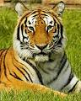
Fill in the double-bubble map to tell the similarities and differences between the Indian Star Tortoise and the Indian Bengal tiger.

Star
Tortoise
Bengal
Tiger

